|  |  |  |  |
| --- | --- | --- | --- |
| **Name of Student: NINAD AVINASH PATIL** | | | |
| **Roll No: 33** | | **Lab Practical Number: 5(A).2** | |
| **Title of Lab Practical: Create an ASP.NET web page to add multiple cookies in an application and display the same.** | | | |
| **DOP: 21/04/2021** | | **DOS: 27/04/2021** | |
| **CO Mapped: CO1** | **PO Mapped: PO3, PO5, PO7,**  **PO12, PSO1, PSO2** | **Faculty Signature:** | **Marks:** |

**Practical No 5(A).2**

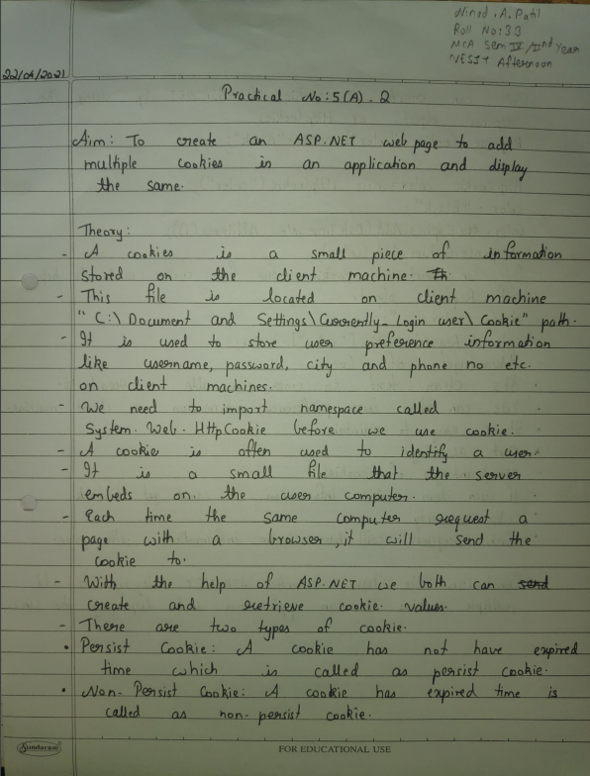

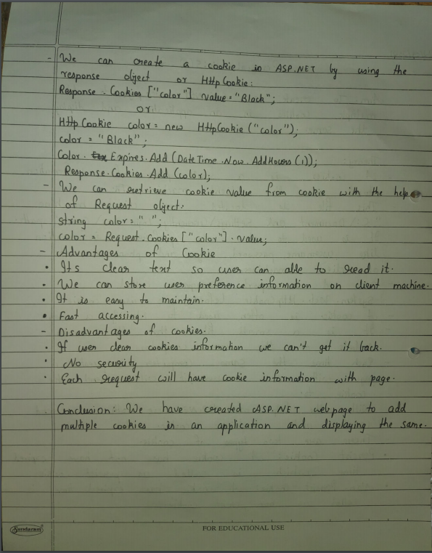

**Code:**

**WebForm1.aspx**

<%@ Page Language="C#" AutoEventWireup="true" CodeBehind="WebForm1.aspx.cs" Inherits="P5A2.WebForm1" %>

<!DOCTYPE html PUBLIC "-//W3C//DTD XHTML 1.0 Transitional//EN" "http://www.w3.org/TR/xhtml1/DTD/xhtml1-transitional.dtd">

<html xmlns="http://www.w3.org/1999/xhtml">

<head runat="server">

<title></title>

</head>

<body>

<form id="form1" runat="server">

<div>

UserName :

<asp:TextBox ID="TextBox1" runat="server"></asp:TextBox>

<br /> <br />

Password &nbsp; :

<asp:TextBox ID="TextBox2" runat="server"></asp:TextBox>

<br /> <br />

<asp:Button ID="Button1" runat="server" onclick="Button1_Click" Text="AddCookie" />

</div>

</form>

</body>

</html>

**WebForm1.aspx.cs**

using System;

using System.Collections.Generic;

using System.Linq;

using System.Web;

using System.Web.UI;

using System.Web.UI.WebControls;

namespace P5A2

{

public partial class WebForm1 : System.Web.UI.Page

{

protected void Page_Load(object sender, EventArgs e)

{ }

protected void Button1_Click(object sender, EventArgs e)

{

try

{

HttpCookie cookie = new HttpCookie("MyCookie");

cookie["a"] = TextBox1.Text;

cookie["b"] = TextBox2.Text;

cookie.Expires = DateTime.Now.AddSeconds(15);

Response.Cookies.Add(cookie);

Response.Redirect("WebForm2.aspx");

}

catch (Exception ex)

{

Response.Write("<script>alert('Fields are empty !!!!!!')</script>");

} } } }

**WebForm2.aspx**

<%@ Page Language="C#" AutoEventWireup="true" CodeBehind="WebForm2.aspx.cs" Inherits="P5A2.WebForm2" %>

<!DOCTYPE html PUBLIC "-//W3C//DTD XHTML 1.0 Transitional//EN" "http://www.w3.org/TR/xhtml1/DTD/xhtml1-transitional.dtd">

<html xmlns="http://www.w3.org/1999/xhtml">

<head runat="server">

<title></title>

</head>

<body>

<form id="form1" runat="server">

<div>

<asp:Button ID="Button1" runat="server" onclick="Button1_Click" Text="ReadCookie" />

&nbsp;&nbsp;&nbsp;

<asp:Button ID="Button2" runat="server" onclick="Button2_Click" Text="DeleteCookie" />

</div>

</form>

</body>

</html>

**WebForm2.aspx.cs**

using System;

using System.Collections.Generic;

using System.Linq;

using System.Web;

using System.Web.UI;

using System.Web.UI.WebControls;

namespace P5A2

{

public partial class WebForm2 : System.Web.UI.Page {

protected void Page_Load(object sender, EventArgs e)

{ }

protected void Button1_Click(object sender, EventArgs e)

{

try

{

string s = Request.Cookies["MyCookie"]["a"];

string ss = Request.Cookies["MyCookie"]["b"];

Response.Write("CookieUser : <b>" + s + "</b> <br/>CookiePassword : <b>" + ss + "</b><br/><br/>");

}

catch (Exception ex)

{

Response.Write("<script>alert('Cookies are empty !!')</script>");

} }

protected void Button2_Click(object sender, EventArgs e)

{

try

{

HttpCookie cookie = Request.Cookies["MyCookie"];

cookie.Expires = DateTime.Now.AddMilliseconds(-10);

Response.Cookies.Add(cookie);

}

catch (Exception ex)

{

Response.Write("<script>alert('Cookies already expired !!!!!!')</script>");

}

}

}

}

**Output:**

